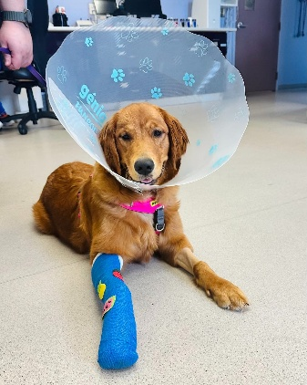
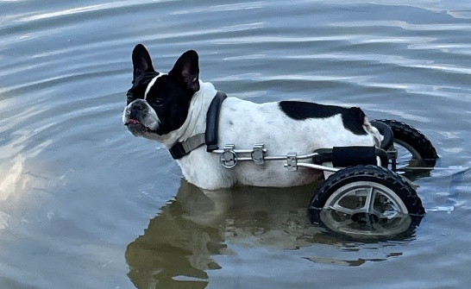
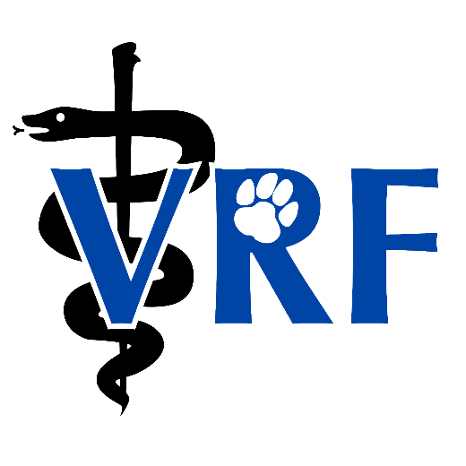
Wags N Whiskers Veterinary
Relief Fund
Monday, June 15
3pm– 10pm
Support us by presenting this flyer to the Fargo, ND Texas Roadhouse and they will donate 10% of your total food purchases to Wags N Whiskers Veterinary Relief Fund!

(701) 282-8590
4971 13th Ave South | City, St

